# General info

You are employee in IT department of commercial bank that has offices in different countries. You receive request to design database for Salary management for the employees across the globe.

You will need to prepare database that will be used to store and manage basic information about the employee and additionally manage monthly salary for each employee.

Following information should exists in your database:

## Seniority level

### Columns:

* Id
* Name

### Data:

Seniority levels should be inserted manually.

Following data should be inserted:

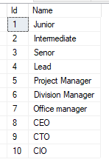

Table should contain 10 records after import.

## Location

### Columns:

* Id
* CountryName
* Continent
* Region

### Data:

List of locations should be imported from Application.Countries table in WideWorldImporters database.

Table should contain 190 records after import.

## Department

### Columns:

* Id
* Name

### Data:

Departments should be inserted manually.

Following data should be inserted:

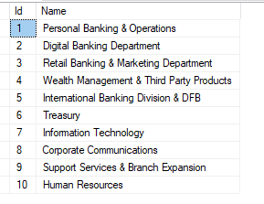

Table should contain 10 records after import.

## Employee

### Columns:

* Id
* FirstName
* LastName
* Location
* Seniority level
* Department

### Data:

List of employees should be imported from Application.People table in WideWorldImporters database.

Table should contain 1111 records after import.

How to populate Location, Seniority and Department data:

* Seniority level:
  + We have 10 different seniority levels, so all employees should be divided in almost equal groups and ~10% of employees should have ‘Junior’ seniority, 10% “Intermediate” and so on.
* Departments:
  + We have 10 different departments, so all employees should be divided in almost equal groups and ~10% of employees should belong to ‘Personal Banking & Operations’ department, ~10% “Treasury” department and and so on.
* Location
  + We have 190 different departments, so all employees should be divided in almost equal groups and we need to have approx. 5-6 employees on each location.
  + Example: Employee 1,2,3,4,5,6 should be on location 1, Employees 7,8,9,10,11,12 should be on location 2 etc.

## Salary

### Columns:

* Id
* EmployeeId
* Month
* Year
* GrossAmount
* NetAmount
* RegularWorkAmount
* BonusAmount
* OvertimeAmount
* VacationDays
* SickLeaveDays

### Data:

Salary data should be generated with SQL Script.

Following data should be inserted:

* Salary data for the past 20 years, starting from 01.2001 to 12.2020
* Gross amount should be random data between 30.000 and 60.000
* Net amount should be 90% of the gross amount
* RegularWorkAmount sould be 80% of the total Net amount for all employees and months
* Bonus amount should be the difference between the NetAmount and RegularWorkAmount for every Odd month (January,March,..)
* OvertimeAmount should be the difference between the NetAmount and RegularWorkAmount for every Even month (February,April,…)
* All employees use 10 vacation days in July and 10 Vacation days in December
* Additionally random vacation days and sickLeaveDays should be generated with the following script:

update dbo.salary set vacationDays = vacationDays + (EmployeeId % 2)

where (employeeId + MONTH+ year)%5 = 1

GO

update dbo.salary set SickLeaveDays = EmployeeId%8, vacationDays = vacationDays + (EmployeeId % 3)

where (employeeId + MONTH+ year)%5 = 2

GO

If everything is done as expected the following query should return 0 rows:

select * from dbo.salary

where NetAmount <> (regularWorkAmount + BonusAmount + OverTimeAmount)

Additionally, vacation days should be between 20 and 30